This SOP explains how to claim one PDU for a PMI Milwaukee SE WI chapter event you had attended and registered for ( if not registered, per ethics rule and in case of an audit, PMI global cannot verify whether you attended or not)
This version was revised in march 2022 after a bug for filing PDUs was reported by all our members.
First go to the invite for the meeting you attended and capture how the PDU is being allocated based on the new Leadership triangle –Education – technical, leadership or strategic & business
Then login to CCRS – this is Global PMI tool for registering PDUs using your global PMI login ( which by the way is the same as your PMI Milwaukee SE WI chapter login) – PDUs are claimed on the PMI global website though.
https://ccrs.pmi.org/
as a reminder, here are the minimum to get recertified within your 3 years cycle
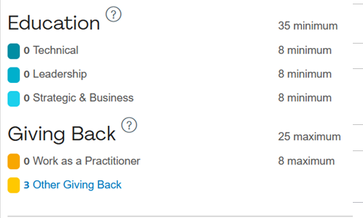

Then from main menu, go to PDUs, report PDUs
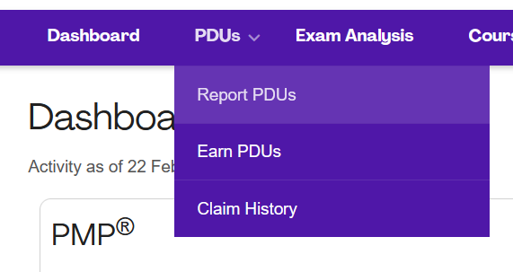
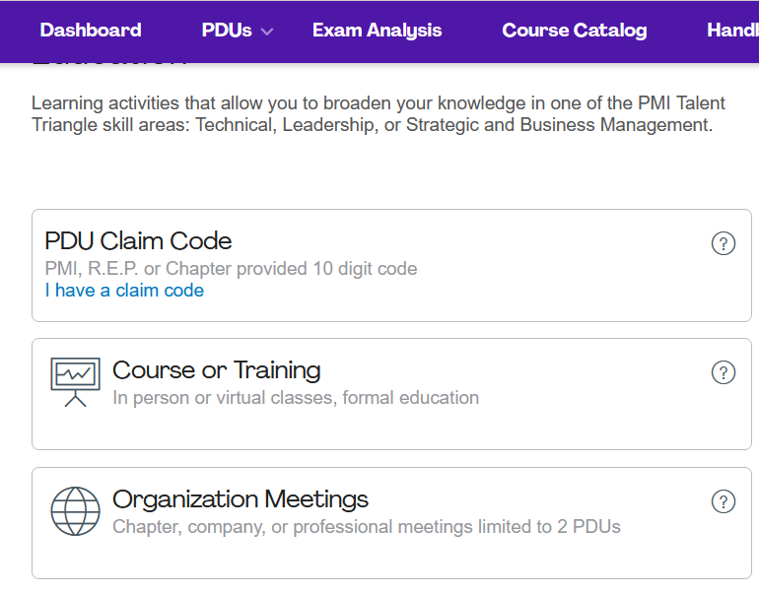

Example on how to report our Feb 16th 2022 chapter event.
The workaround provided by PMI and tested by a couple of members includes the following.
Do not select from the name of the chapter from the pulldown menu the form. Just type the entire name of the chapter manually. PMI is aware but will not fix the bug at the moment.
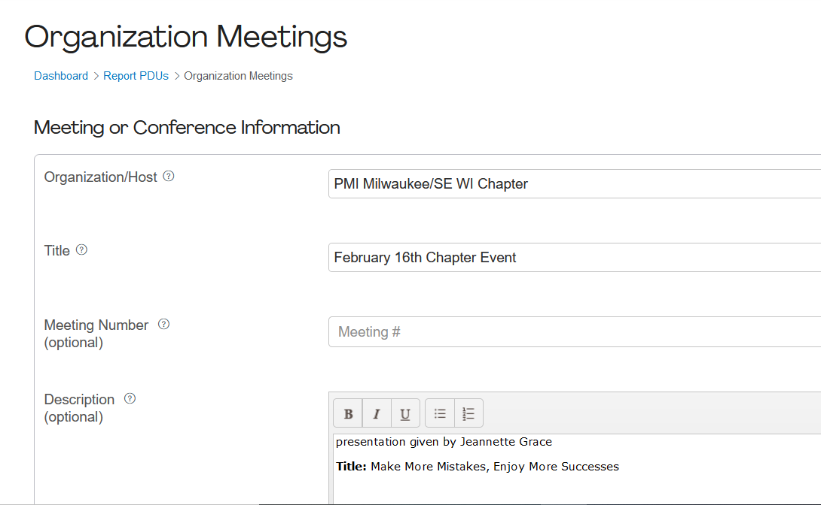

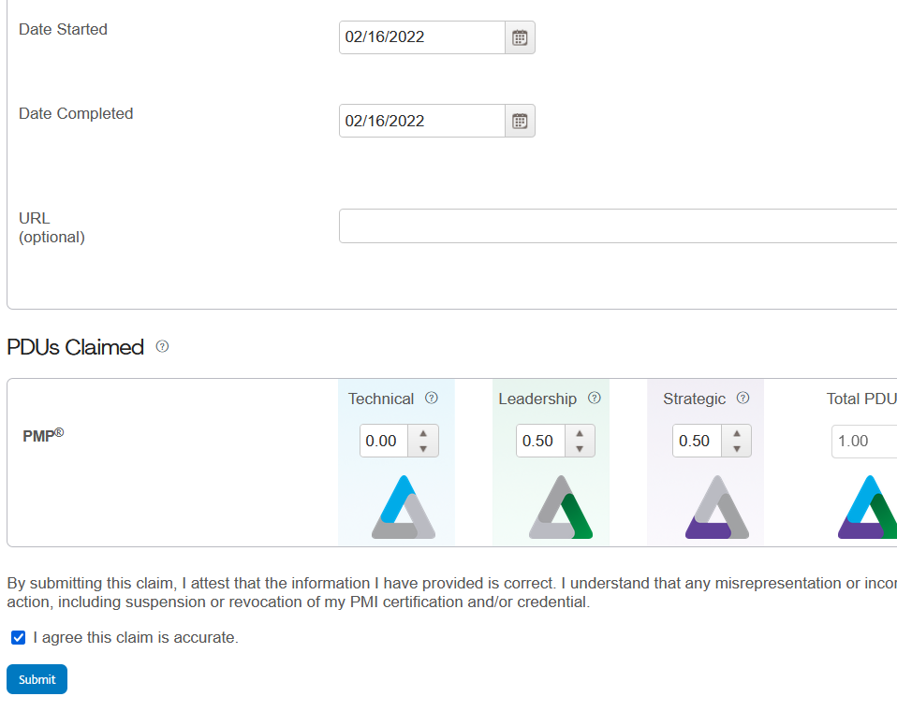

For any question, please contact programs@pmi-milwaukee.org

